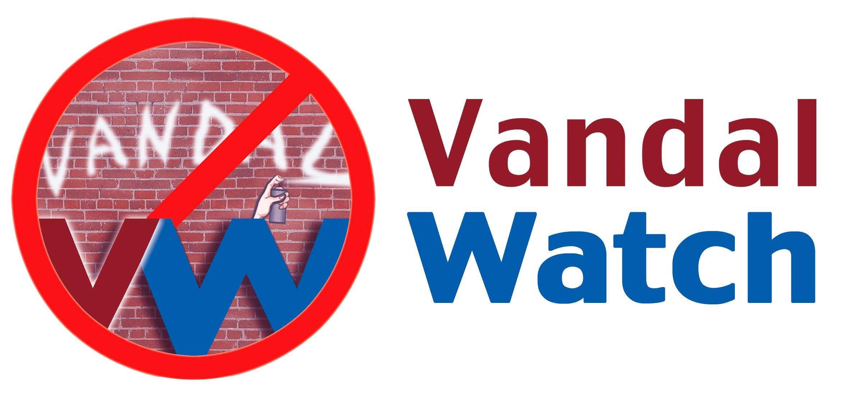

HALLOWEEN ON SATURDAY NIGHT
PLEASE LOOK AFTER THE SCHOOL

Halloween Saturday will likely be very active your neighbourhood. We invite you to make sure that your school remains free from vandalism.

What You Can Do
Keep your eyes and ears open for suspicious activities on the school grounds, especially after-hours. Signs of trouble include late night trespassers and the gathering of unorganized groups of people.

Everything you see and hear helps. Note the physical characteristics and clothing of individuals. If you see automobiles, jot down license plate numbers.

Report All Suspicious Activities to the Vandal Watch Tip Line

604-927-7600

Call immediately when something raises your suspicions,
Do not wait for the damage to be done.

Your Call is Anonymous and Confidential

No one will ask for your name or phone number. The Tip Line is available 24 hours a day. Security personnel will investigate and will take action or involve the police. Do not get involved in a confrontation yourself.

KEEP THE TIP LINE PHONE NUMBER HANDY. MAKE SURE THE PHONE NUMBER IS GIVEN ONLY TO RESPONSIBLE ADULTS.

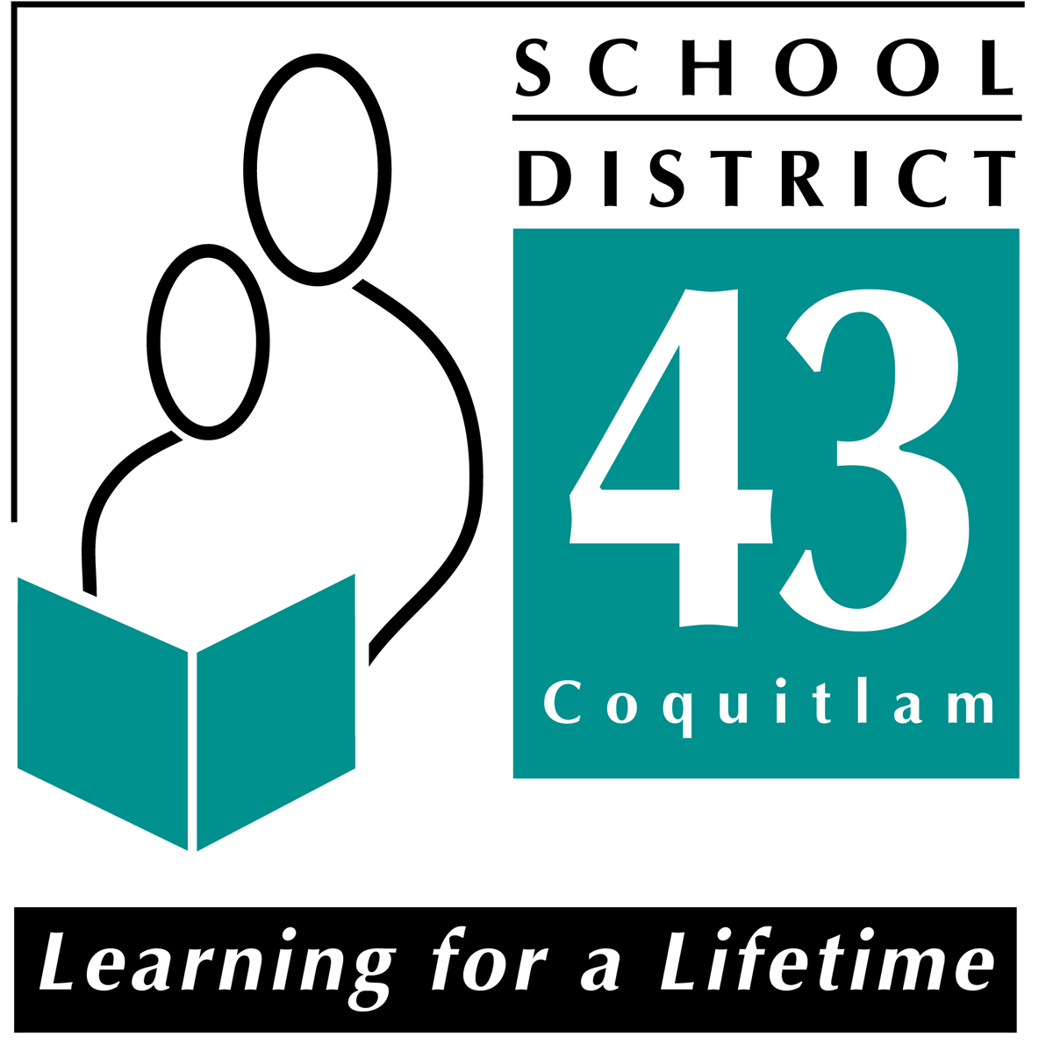

Vandal Watch is a joint community safety program of School District 43 Coquitlam and the City of Port Coquitlam

